* **WEEK – 1(6/01/2025-8/01/2025)**

**--------------**

**SPLASH SCREEN IMPLEMENTATION (JAVA CODE)**

package com.example.healthcareapp;  
import android.content.Intent;  
import android.os.Bundle;  
import android.os.Handler;  
import android.view.WindowManager;  
import androidx.appcompat.app.AppCompatActivity;  
public class SplashActivity extends AppCompatActivity {  
 @Override  
 protected void onCreate(Bundle savedInstanceState) {  
 super.onCreate(savedInstanceState);  
 setContentView(R.layout.*activity_splash*);  
 // for hide the status bar in a screen getWindow().setFlags(WindowManager.LayoutParams.*FLAG_FULLSCREEN*,WindowManager.LayoutParams.*FLAG_FULLSCREEN*);  
 // for splash screen  
 new Handler().postDelayed(new Runnable()  
 {  
 @Override  
 public void run()  
 {  
 Intent intent = new Intent(getApplicationContext(),MainActivity.class);  
 startActivity(intent);  
 finish();  
 }  
 },3000);  
 }}

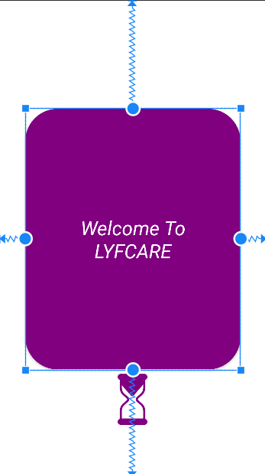

* **WEEK -2(12/01/2025 – 15/01/2025)**

**-------------**

**REGISTRATION PAGE (JAVA CODE)**

package com.example.healthcareapp;  
  
import android.content.Context;  
import android.content.Intent;  
import android.net.ConnectivityManager;  
import android.net.NetworkInfo;  
import android.os.Bundle;  
import android.view.View;  
import android.view.WindowManager;  
import android.widget.Button;  
import android.widget.EditText;  
import android.widget.TextView;  
import android.widget.Toast;  
import androidx.annotation.NonNull;  
import androidx.appcompat.app.AppCompatActivity;  
import com.google.android.gms.tasks.OnCompleteListener;  
import com.google.android.gms.tasks.Task;  
import com.google.firebase.auth.AuthResult;  
import com.google.firebase.auth.FirebaseAuth;  
// for checking the Internet is connect or not..  
import android.content.Context;  
import android.net.ConnectivityManager;  
import android.net.NetworkInfo;  
public class MainActivityRegister extends AppCompatActivity {  
 private FirebaseAuth auth;  
 EditText edUsername,edPassword,edConfirm,edEmail;  
 TextView btn;  
 TextView tv;  
 @Override  
 protected void onCreate(Bundle savedInstanceState) {  
 super.onCreate(savedInstanceState);  
 setContentView(R.layout.*activity_main_register*);  
 auth = FirebaseAuth.*getInstance*();  
 edUsername = findViewById(R.id.*editTextAppFullName*);  
 edPassword = findViewById(R.id.*editTextAppContactNumber*);  
 edConfirm = findViewById(R.id.*editTextAppFees*);  
 edEmail = findViewById(R.id.*forgetpassword*);  
 btn = findViewById(R.id.*buttonRegister*);  
 tv = findViewById(R.id.*textViewExistingUser*); getWindow().setFlags(WindowManager.LayoutParams.*FLAG_FULLSCREEN*,WindowManager.LayoutParams.*FLAG_FULLSCREEN*);  
 tv.setOnClickListener(new View.OnClickListener() {  
 @Override  
 public void onClick(View view) {  
 startActivity(new Intent(MainActivityRegister.this, MainActivity.class));  
 }  
 });  
 btn.setOnClickListener(new View.OnClickListener() {  
 @Override  
 public void onClick(View view)  
 {  
 String username = edUsername.getText().toString();  
 String email = edEmail.getText().toString();  
 String password = edPassword.getText().toString();  
 String confirm = edConfirm.getText().toString();  
 NetworkUtils networkUtils = new NetworkUtils();  
 if(networkUtils.isNetworkAvailable(getApplicationContext())) {  
 if (username.length() == 0 || email.length() == 0 || password.length() == 0 || confirm.length() == 0) {  
 Toast.*makeText*(getApplicationContext(), "Please fill All details", Toast.*LENGTH_SHORT*).show();  
 } else  
 {  
 if (password.compareTo(confirm) == 0) // if the statement is true..  
 {  
 if (*isValid*(password)) {  
  
 // Using FireBase .. as well as store the email and password into the Database..(java)  
  
 auth.createUserWithEmailAndPassword(email, password).addOnCompleteListener(new OnCompleteListener<AuthResult>() {  
 @Override  
 public void onComplete(@NonNull Task<AuthResult> task) {  
 if (task.isSuccessful()) {  
 Toast.*makeText*(getApplicationContext(), "Record Inserted", Toast.*LENGTH_SHORT*).show();  
 startActivity(new Intent(MainActivityRegister.this, MainActivity.class));  
 finish();  
 } else if (email.contains("@gmail.com"))  
 Toast.*makeText*(getApplicationContext(), "Email is already Exists", Toast.*LENGTH_SHORT*).show();  
 else  
 Toast.*makeText*(getApplicationContext(), "Invalid Email", Toast.*LENGTH_SHORT*).show();  
 }  
 });  
 } else {  
 Toast.*makeText*(getApplicationContext(), "passward must be contain 8 characters having letter,digit,special char", Toast.*LENGTH_SHORT*).show();  
 }  
 } else {  
 Toast.*makeText*(getApplicationContext(), "passward didn't match", Toast.*LENGTH_SHORT*).show();  
 }  
 } // inner else close..  
 }// outer if close  
 else  
 {  
 Toast.*makeText*(MainActivityRegister.this, "No Internet Connection", Toast.*LENGTH_SHORT*).show();  
 }}  
 }); // setOnClickListener close  
 } // onCreate() function close  
  
// for the password ==> must contain the letters and digits and special characters  
 public static boolean isValid(String passwodhere)  
 {  
 int f1=0,f2=0,f3=0;  
 if(passwodhere.length()<8)  
 {  
 return false;  
 }  
 else  
 {  
 for(int p=0;p<passwodhere.length();p++)  
 {  
 if(Character.*isLetter*(passwodhere.charAt(p)))  
 f1=1;  
 }  
 for(int r=0;r<passwodhere.length();r++)  
 {  
 if(Character.*isDigit*(passwodhere.charAt(r)))  
 f2=1;  
 }  
 for(int s=0;s<passwodhere.length();s++)  
 {  
 char c = passwodhere.charAt(s);  
 if(c>=33 && c<=46 || c==64)  
 f3=1;  
 }  
 if(f1==1 && f2==1 && f3==1)  
 return true;  
 return false;  
 }  
 }  
 // Internet Connection is on or off.  
 public class NetworkUtils {  
 public boolean isNetworkAvailable(Context context) {  
 ConnectivityManager connectivityManager =  
 (ConnectivityManager) context.getSystemService(Context.*CONNECTIVITY_SERVICE*);  
 if (connectivityManager != null) {  
 NetworkInfo activeNetworkInfo = connectivityManager.getActiveNetworkInfo();  
 return activeNetworkInfo != null && activeNetworkInfo.isConnected();  
 }  
 return false;  
 }  
 } // close  
} // MainActivity close

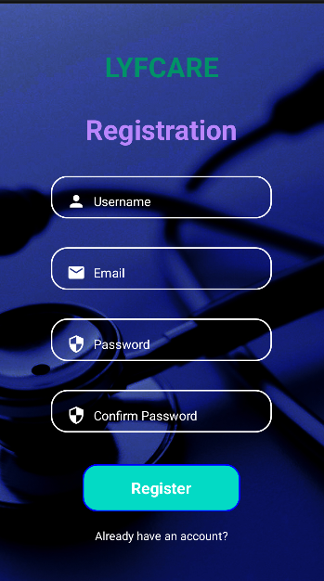

* **WEEK-3(21/01/25 – 25/01/25)**

**---------------**

**LOGIN AND FORGET PASSWORD PAGE**

package com.example.healthcareapp;  
import android.content.Intent;  
import android.os.Bundle;  
import android.os.Handler;  
import android.util.Patterns;  
import android.view.View;  
import android.view.WindowManager;  
import android.widget.Button;  
import android.widget.EditText;  
import android.widget.TextView;  
import android.widget.Toast;  
import androidx.activity.EdgeToEdge;  
import androidx.annotation.NonNull;  
import androidx.appcompat.app.AppCompatActivity;  
import androidx.core.graphics.Insets;  
import androidx.core.view.ViewCompat;  
import androidx.core.view.WindowInsetsCompat;  
import com.airbnb.lottie.LottieAnimationView;  
import com.google.android.gms.tasks.OnFailureListener;  
import com.google.android.gms.tasks.OnSuccessListener;  
import com.google.firebase.auth.AuthResult;  
import com.google.firebase.auth.FirebaseAuth;  
import android.content.Context;  
import android.net.ConnectivityManager;  
import android.net.NetworkInfo;  
import org.w3c.dom.Text;  
public class MainActivity extends AppCompatActivity {  
 private FirebaseAuth auth;  
 EditText edUsername,edPassward;  
 TextView btn;  
 TextView tv,ForgetPassword;  
 @Override  
 protected void onCreate(Bundle savedInstanceState) {  
 super.onCreate(savedInstanceState);  
 setContentView(R.layout.*activity_main*);  
 auth = FirebaseAuth.*getInstance*();  
 ForgetPassword = findViewById(R.id.*textViewForgetPassword*);  
 edUsername = findViewById(R.id.*editTextLoginUsername*);  
 edPassward = findViewById(R.id.*editTextLoginPassword*);  
 btn = findViewById(R.id.*buttonLogin*);  
 tv = findViewById(R.id.*textViewNewUser*);  
 // lottie animation id find  
 LottieAnimationView animation = findViewById(R.id.*animation*); getWindow().setFlags(WindowManager.LayoutParams.*FLAG_FULLSCREEN*,WindowManager.LayoutParams.*FLAG_FULLSCREEN*);  
 btn.setOnClickListener(new View.OnClickListener() {  
 @Override  
 public void onClick(View view) {  
 String username = edUsername.getText().toString();  
 String passward = edPassward.getText().toString();  
 // 1. if username and passward are empty then given toast is show()  
 if(username.length()==0 || passward.length()==0)  
 {  
 Toast.*makeText*(getApplicationContext(),"Please fill All details",Toast.*LENGTH_SHORT*).show();  
 }  
 else {  
 // to check the internet connection is on or off  
 NetworkUtils networkUtils = new NetworkUtils();  
 if (networkUtils.isNetworkAvailable(getApplicationContext()))  
 {  
 // for Database username and password checking..  
 if (!username.isEmpty() && Patterns.*EMAIL_ADDRESS*.matcher(username).matches()) {  
 if (!passward.isEmpty()) {  
 auth.signInWithEmailAndPassword(username, passward)  
 .addOnSuccessListener(new OnSuccessListener<AuthResult>() {  
 @Override  
 public void onSuccess(AuthResult authResult) {  
  
 animation.playAnimation();  
  
 new Handler().postDelayed(new Runnable() {  
 @Override  
 public void run() {  
 startActivity(new Intent(MainActivity.this, MainActivityHome.class));  
 Toast.*makeText*(getApplicationContext(), "Login success", Toast.*LENGTH_SHORT*).show();  
 finish();  
 }  
 }, animation, 3500);  
  
// startActivity(new Intent(MainActivity.this, MainActivityHome.class));  
// Toast.makeText(getApplicationContext(), "Login success", Toast.LENGTH_SHORT).show();  
// finish();  
 }  
 }).addOnFailureListener(new OnFailureListener() {  
 @Override  
 public void onFailure(@NonNull Exception e) {  
 Toast.*makeText*(getApplicationContext(), "Login Fail", Toast.*LENGTH_SHORT*).show();  
 }  
 });  
 } // inner if loop close  
 } // outer if loop close  
 }//network close  
  
 else {  
 Toast.*makeText*(MainActivity.this, "No Internet Connection", Toast.*LENGTH_SHORT*).show();  
 }  
 } // else close  
 } // onclick method close  
 }); // setOnClick method close  
 // 2. it's is a Intent page ==> go to the new Register page..(New User)  
 tv.setOnClickListener(new View.OnClickListener() {  
 @Override  
 public void onClick(View view) {  
 startActivity(new Intent(MainActivity.this, MainActivityRegister.class));  
 finish();  
 }  
 });  
  
  
 ForgetPassword.setOnClickListener(new View.OnClickListener() {  
 @Override  
 public void onClick(View view) {  
 startActivity(new Intent(MainActivity.this, ForgetActivity.class));  
 }  
 });  
 }  
 // for internet check..  
 public class NetworkUtils {  
 public boolean isNetworkAvailable(Context context) {  
 ConnectivityManager connectivityManager =  
 (ConnectivityManager) context.getSystemService(Context.*CONNECTIVITY_SERVICE*);  
 if (connectivityManager != null) {  
 NetworkInfo activeNetworkInfo = connectivityManager.getActiveNetworkInfo();  
 return activeNetworkInfo != null && activeNetworkInfo.isConnected();  
 }  
 return false;  
 }  
 } // close  
}

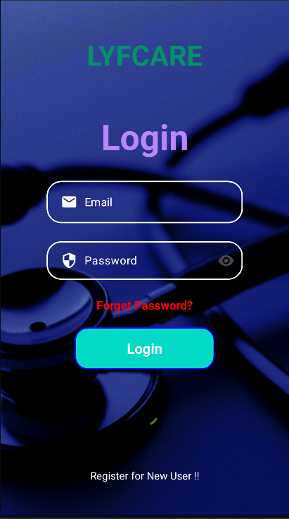

**FOR FORGET PAGE**

package com.example.healthcareapp;  
import android.content.Intent;  
import android.os.Bundle;  
import android.view.View;  
import android.view.WindowManager;  
import android.widget.Button;  
import android.widget.EditText;  
import android.widget.Toast;  
import androidx.annotation.NonNull;  
import androidx.appcompat.app.AppCompatActivity;  
import com.google.android.gms.tasks.OnCompleteListener;  
import com.google.android.gms.tasks.Task;  
import com.google.firebase.auth.FirebaseAuth;  
public class ForgetActivity extends AppCompatActivity {  
 EditText txtemail ,password;  
 Button forbtn;  
 private FirebaseAuth auth;  
 private String email;  
 @Override  
 protected void onCreate(Bundle savedInstanceState) {  
 super.onCreate(savedInstanceState);  
 setContentView(R.layout.*activity_forget*);  
 auth = FirebaseAuth.*getInstance*();  
 txtemail = findViewById(R.id.*forgetemail*);  
 forbtn = findViewById(R.id.*forgetbtn*);  
  
  
 getWindow().setFlags(WindowManager.LayoutParams.*FLAG_FULLSCREEN*,WindowManager.LayoutParams.*FLAG_FULLSCREEN*);  
 forbtn.setOnClickListener(new View.OnClickListener() {  
 @Override  
 public void onClick(View view) {  
 validateData(); // method  
 }  
 });  
  
 }  
 private void validateData()  
 {  
 email = txtemail.getText().toString();  
 if(email.isEmpty())  
 {  
 txtemail.setError("Required"); // Tost message by the predefine function  
 }  
 else  
 {  
 forgetpass();// method call  
 }  
 }  
 private void forgetpass()  
 {  
 auth.sendPasswordResetEmail(email).addOnCompleteListener(new OnCompleteListener<Void>() {  
 @Override  
 public void onComplete(@NonNull Task<Void> task) {  
 if(task.isSuccessful())  
 {  
 Toast.*makeText*(getApplicationContext(), "Check your Email", Toast.*LENGTH_SHORT*).show();  
 startActivity(new Intent(ForgetActivity.this, MainActivity.class));  
 finish();  
 }  
 else  
 {  
 Toast.*makeText*(getApplicationContext(), "Unable to send,failed", Toast.*LENGTH_SHORT*).show();  
 }  
  
 }  
 }); // auth sendPasswordEmail  
 }

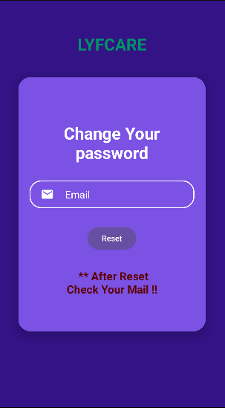

* **WEEK – 4 (28/01/25 – 04/01/25)**

**--------------**

**HOME PAGE(DASHBOARD)**

package com.example.healthcareapp;  
import android.content.Intent;  
import android.net.Uri;  
import android.os.Bundle;  
import android.transition.Slide;  
import android.view.View;  
import android.view.WindowManager;  
import androidx.appcompat.app.AppCompatActivity;  
import androidx.cardview.widget.CardView;  
import java.util.ArrayList;  
public class MainActivityHome extends AppCompatActivity {  
 @Override  
 protected void onCreate(Bundle savedInstanceState) {  
 super.onCreate(savedInstanceState);  
 setContentView(R.layout.*activity_main_home*);  
 getWindow().setFlags(WindowManager.LayoutParams.*FLAG_FULLSCREEN*,WindowManager.LayoutParams.*FLAG_FULLSCREEN*);  
 CardView exit = findViewById(R.id.*cardExit*);  
 exit.setOnClickListener(new View.OnClickListener() {  
 @Override  
 public void onClick(View view) {  
  
 // it's moves to current activity to MainActivity(Login)  
 startActivity(new Intent(MainActivityHome.this,MainActivity.class));  
 finish();  
 }  
 });  
 CardView findDoctor = findViewById(R.id.*cardFindDoctor*);  
 findDoctor.setOnClickListener(new View.OnClickListener() {  
 @Override  
 public void onClick(View view) {  
 startActivity(new Intent(MainActivityHome.this,FindDoctorActivity.class));  
 }  
 });  
  
  
 // FOR BUY LabTest  
 CardView buymedicine = findViewById(R.id.*cardLabTest*);  
 buymedicine.setOnClickListener(new View.OnClickListener() {  
 @Override  
 public void onClick(View view) {  
 startActivity(new Intent(MainActivityHome.this,LabTestActivity.class));  
 }  
 });  
  
 // for HealthArticles  
 CardView cardHealthArticles = findViewById(R.id.*cardHealthArticles*);  
 cardHealthArticles.setOnClickListener(new View.OnClickListener() {  
 @Override  
 public void onClick(View view) {  
 startActivity(new Intent(MainActivityHome.this,HealthArticlesActivity.class));  
 }  
 });  
  
 // for mail  
 CardView cardCheckMail = findViewById(R.id.*cardCheckMail*);  
 cardCheckMail.setOnClickListener(new View.OnClickListener() {  
 @Override  
 public void onClick(View view) {  
 Intent intent = new Intent(Intent.*ACTION_VIEW*);  
 intent.setData(Uri.*parse*("https://mail.google.com/mail/u/0/"));  
 startActivity(intent);  
 }  
 });  
  
 // for pay  
 CardView cardpay = findViewById(R.id.*cardpay*);  
 cardpay.setOnClickListener(new View.OnClickListener() {  
 @Override  
 public void onClick(View view) {  
 startActivity(new Intent(MainActivityHome.this,paymentActivity.class));  
 }  
 });  
 }  
}

